**Demonstration of Existing case scenario:**

SQL based jobs are configured as START jobs in IWA and the its query output is passed as an input parameter to its subsequent MAIN jobs.

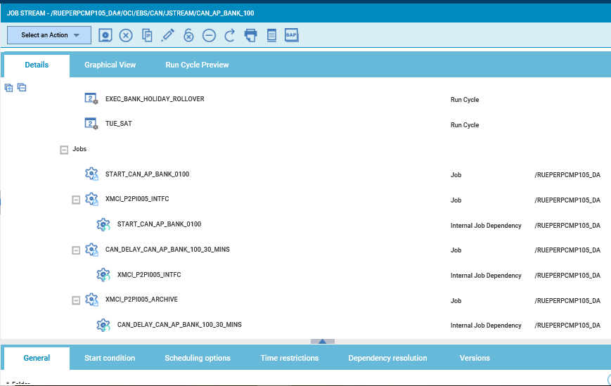

Configuration of START jobs:

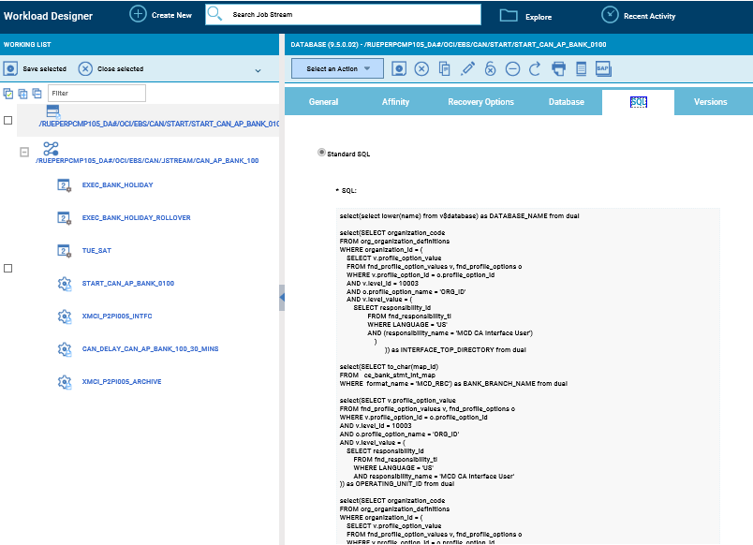

IWA Log of START Job:

The Query output is retrieved and displayed in the job log as shown in the below snapshot.

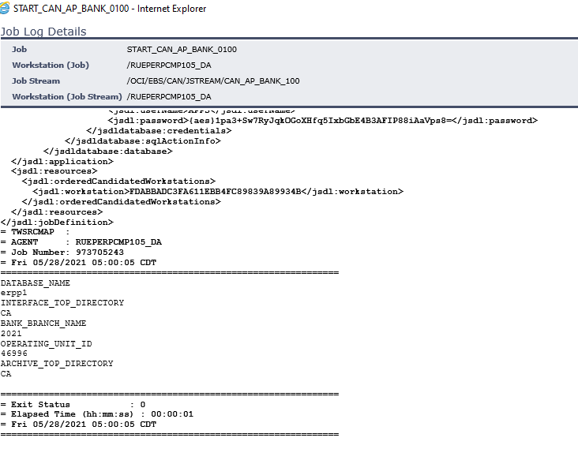

Configuration of MAIN job:

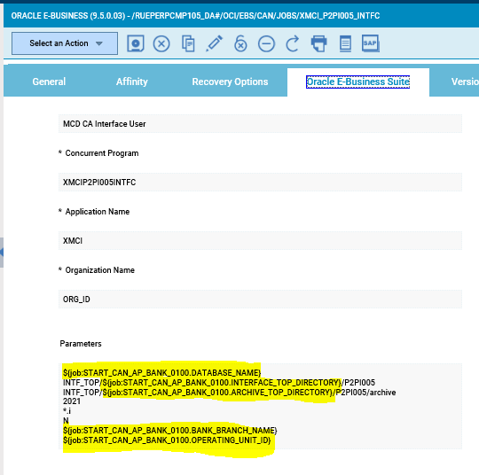

IWA Log of MAIN Job:

Whereas in the MAIN job log the START job names are getting reflected in the parameter field values. The output of the START job query which is passed as input parameter to its subsequent MAIN job is not displayed in the log

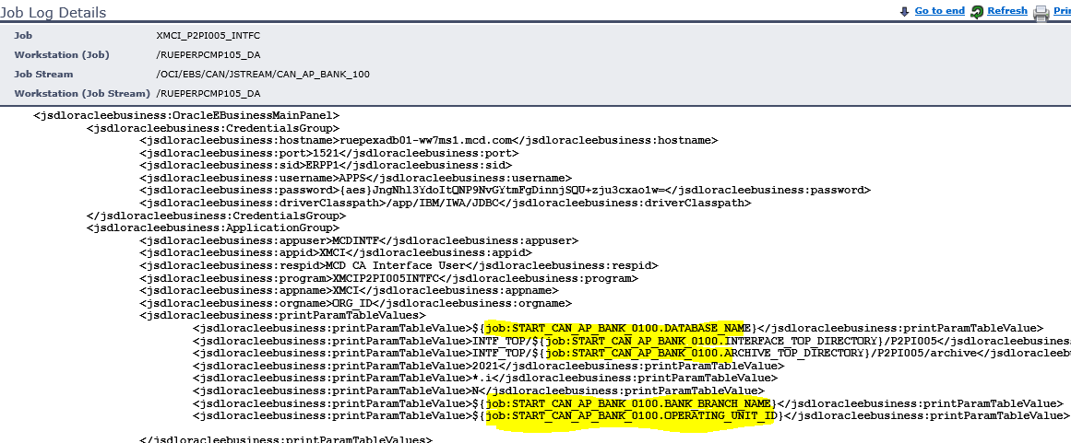

**Requirement as per case TS005744863:**

Our requirement is to get the original output value of the START job to get printed in the log of its subsequent MAIN job instead of the START job name getting printed at present.