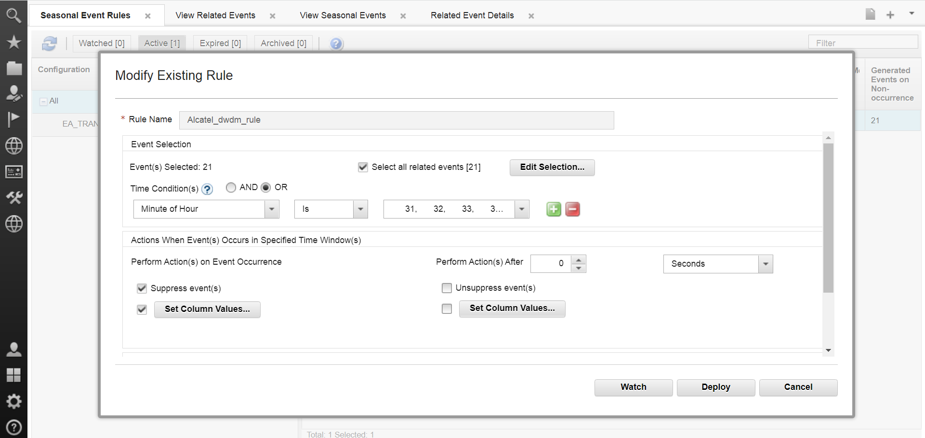

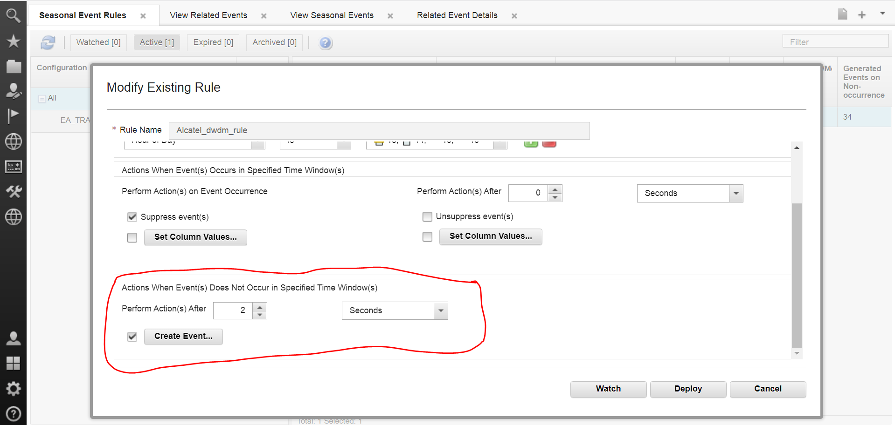

The number of synthetic alarms getting on non-occurrence is equal to the number of related events selected (21 events are selected above, 21 synthetics are generated)

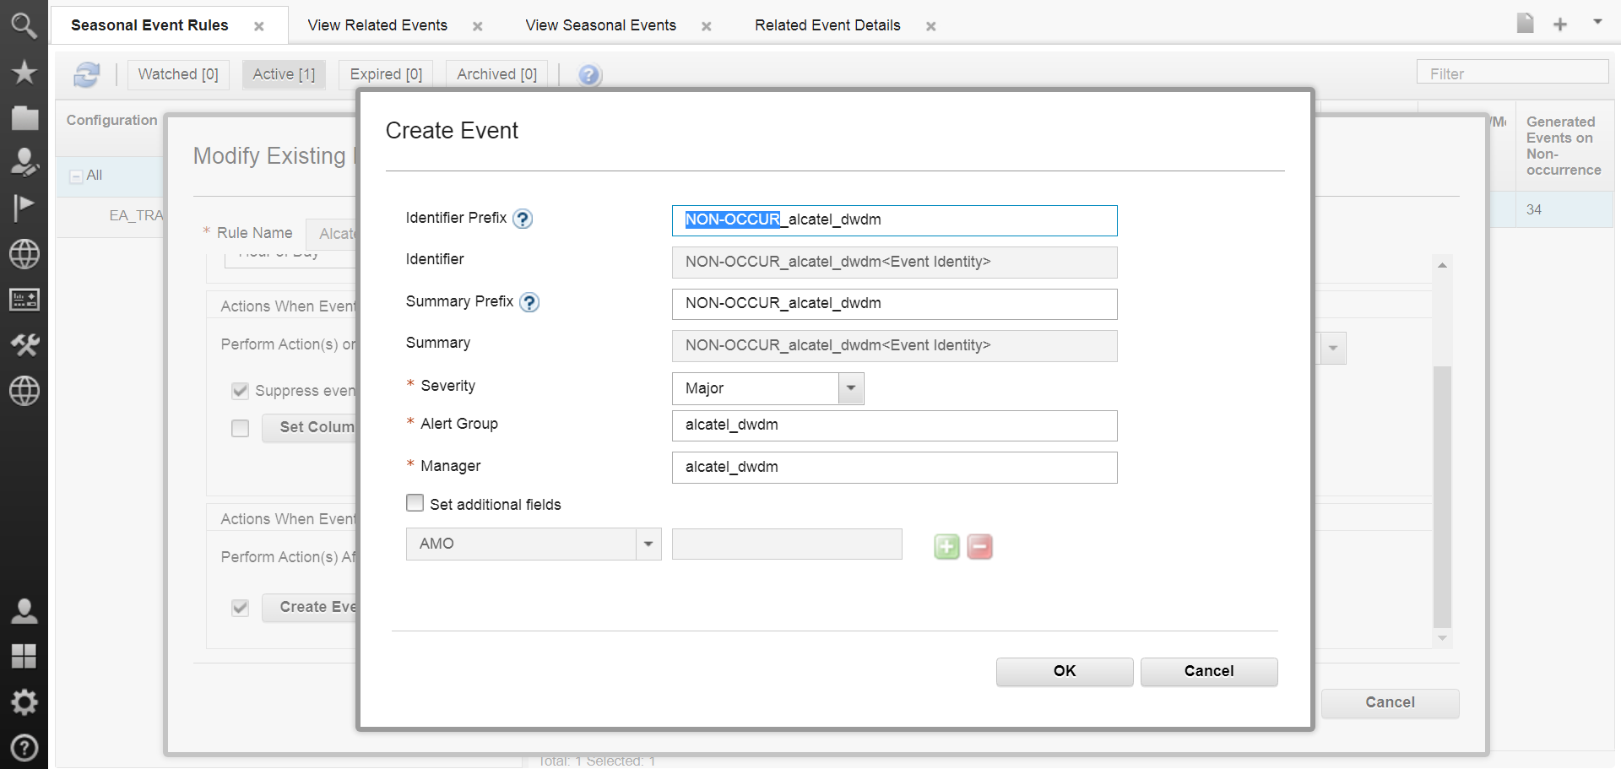

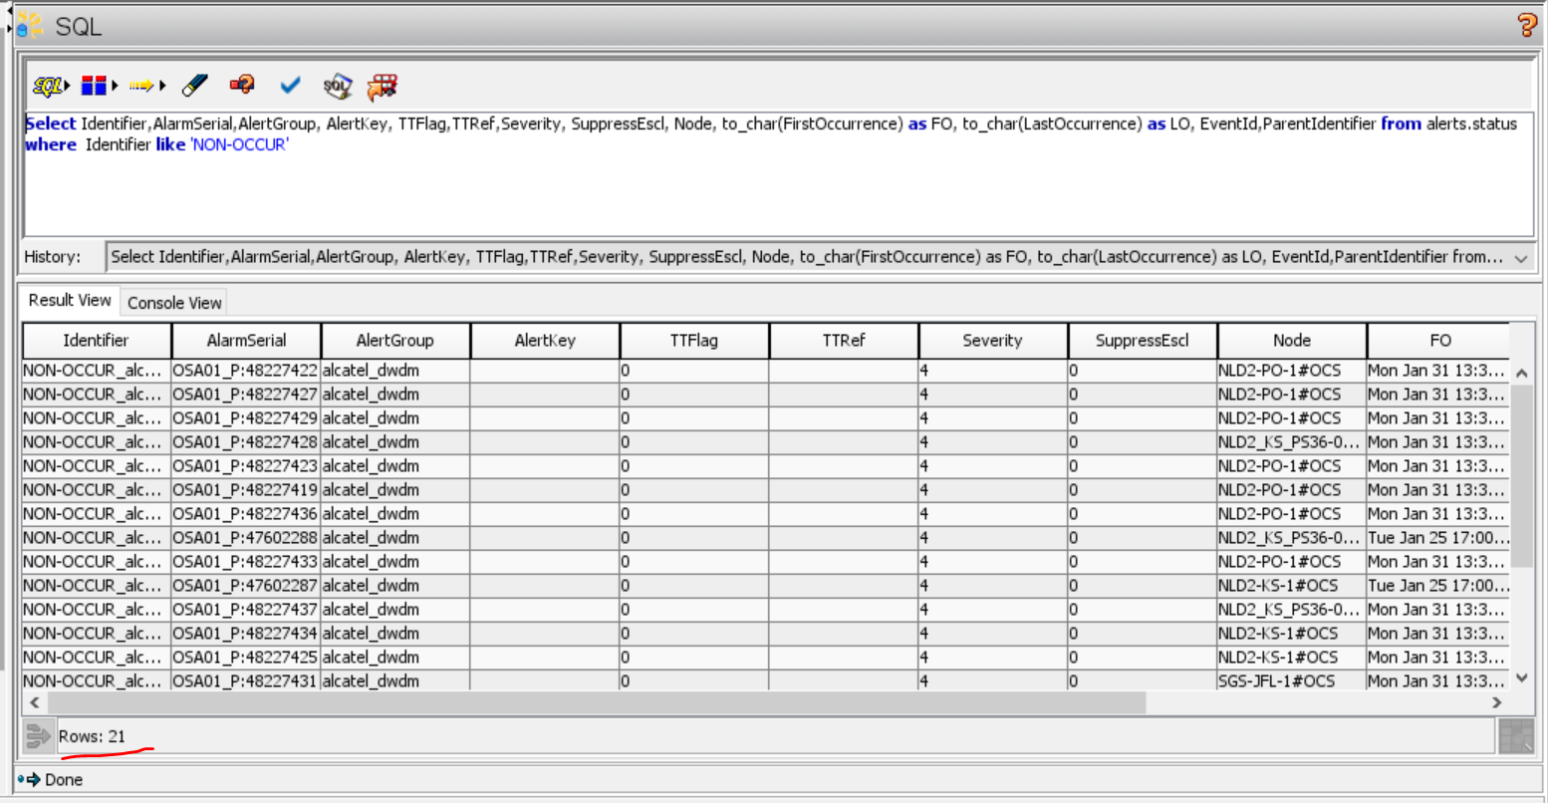

21 synthetic events are getting generated instead of 1 synthetic for the whole related event group

