View Related Events page:
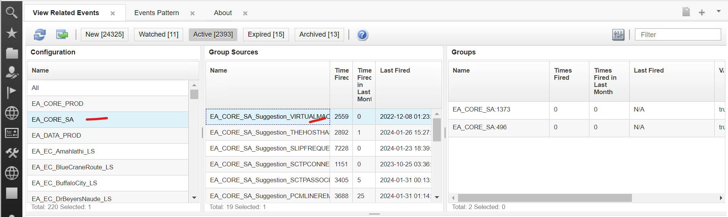
Editing the pattern:
Requirement: To expose the below page to an external application and when the users clicks on a button (pattern name), it should direct that specific pattern.
https://netcool02-sa.vodacom.corp:17311/ibm/console/navigation.do?XSS=4f92c8fc737609928d9412c2330e3f94&wpageid=com.ibm.isclite.welcomeportlet.layoutElement.A&moduleRef=com.ibm.isclite.ISCAdminPortlet&isLoginURL=true#tip.1706679905988
