

Solution Document
for FM and PM Data Retrieval
From Tejas NMS

Version 1.1

Template ID: D – NMS_DD; Ver 1.1
Revision History:
Revision | Date | Author | Reason | Reviewed By | Approved By
0.1 | 5th May 2016 | Narasimha Murthy N. | Version released for review | Vijayakumar V A, Manish Upadhyaya, Tarun Sen, Shekhar Kataray
1.0 | 5th May 2016 | Narasimha Murthy N. | Review comments incorporated | None | Vijayakumar V A
1.1 | 4th Dec 2019 | Kumarasamy Raja | Updating the MTOSI Enhancements | Shekhar Kataray, Gayathri

Review History:
Revision | Review Date | Reviewer(s) | Review Comments
0.1 | 5th May 2016 | Vijayakumar V A, Manish Upadhyaya, Tarun Sen, Shekhar Kataray | Reviewed through Email
1.0 | 6 Dec 2019 | Shekhar Kataray,Gayathri | Reviewed through Email

Acronyms:
Acronyms | Description
FM | Fault Management
MTOSI | Multi-Technology Operations Systems Interface
PM | Performance Management
RRD | Round-Robin Database (Format used by EMS for storing PM files)
TejEMS | Tejas EMS (Tj5100)
TejNMS | Tejas NMS (Tj5500)
TMF | TeleManagement Forum
WSDL | Web Services Description Language

Table of Contents

1 Introduction 6
1.1 What is new in this version (R1.1) 6
1.2 Requirement 7
1.3 Document Objectives 7
1.4 Scope 7
1.5 Intended Audience 7
1.6 Nomenclature 7
1.7 Applicable Standards 7
1.8 References 7
2 Solution Description 7
2.1 PM Data Retrieval 8
2.2 FM Data Retrieval 9
2.2.1 Active Alarm Retrieval 9
2.2.2 Active Alarm Count Retrieval 10
2.2.3 Subscribing For Notification 11
2.2.4 Unsubscribing For Alarm Notification 14
2.3 FM Data Handle 15
2.3.1 Acknowledgement For Alarm Notification 15
2.3.2 UnAcknowledgement For Alarm Notification 16
2.4 FM Data Control 16
2.4.1 Block Alarm Processing 17
2.4.2 Unblock Alarm Processing 19
3 OSS Subscription - Sequence Diagrams 21
3.1 Scenario #1 21
3.2 Scenario #2 22
3.3 Scenario #3 22
3.4 Scenario #4 23
3.5 Scenario #5 24
4 Appendix 25
4.1 Notification Id Generation 25
4.2 Query Expression Filter 26
4.3 Buffering of notifications 26
4.4 Additional information in Object name 27
4.5 Link information for PTP Alarms 29
4.6 Configure MTOSI Services - NMS System 30
4.7 Tejas Proprietary API - Alarm Control 31
4.8 NMS Hot Standby switchover 32

Introduction

What is new in this version (R1.1)
Added QueryExpression filter in the Alarm retrieval (GetActiveAlarms,GetActiveAlarmsCount) –Section 2.2.1 Active Alarm Retrieval
Included the various notification type for the OSS client –Section 2.2.3 Subscribing For Notification
Updated the notifications type affected while unsubscribing – Section 2.2.4 Unsubscribing For Alarm Notification
Updated the business rule for the notificationId ,osTime, objectName fields and link information for PTP alarms in X733_AdditionalInformation field of AlarmType notification. –Section 2.2.3.1 Alarm Notification
Added the Heartbeat notification and Event loss occurred/cleared notifications – Section 2.2.3.2 Heartbeat Notification & 2.2.3.3 Event Loss occurred/cleared Notification
Added the Acknowledge Alarms & UnAcknowledge Alarms API – Section 2.3 FM Data Handle.
Added the Block Alarm processing and Unblock Alarm processing proprietary API – Section 2.4 FM Data Control
Sequence diagram describing the various scenarios possible in NMS-OSS Subscription and notification – Section 3 OSS Subscription - Sequence Diagrams
Added the Appendix for the below points.
- Notification Id generation of alarms – Section 4.1 Notification Id Generation
- Query Exprssion filter of Alarm Retrieval ( GetActiveAlarms,GetActiveAlarmsCount ) – Section 4.2 Query Expression Filter.
- Alarms buffering at the NMS system for handling the temporary network connectivity loss between NMS & OSS – Section 4.3 Buffering of notifications
- Object name to hold all the information to identify alarm in NMS system – Section 4.4 Additional information in Object name
- Link information for PTP Alarms – Section 4.5 Link information for PTP Alarms
- Configuring MTOSI Services in NMS via mtosi.properties - Section 4.6 Configure MTOSI Services - NMS System
- Information about the Tejas Proprietary API Alarm control - Section 4.7 Tejas Proprietary API - Alarm Control
- NMS Hot standby process and proposed setup - Section 4.8 NMS Hot Standby switchover

Requirement
OSSs in Bharti network want to periodically collect PM data and Active FM data from TejNMS.

Document Objectives
This document provides a detailed solution for the requirement.

Scope
This document explains the interface between OSS and NMS for the requirement mentioned in previous section.

Intended Audience
Architects, PLM and Sales.
PLM and Sales shall get this document ratified by the customer.

Nomenclature
None

Applicable Standards
TMF MTOSI v1.0

References
None

Solution Description
Following diagram depicts the interfaces between different layers.
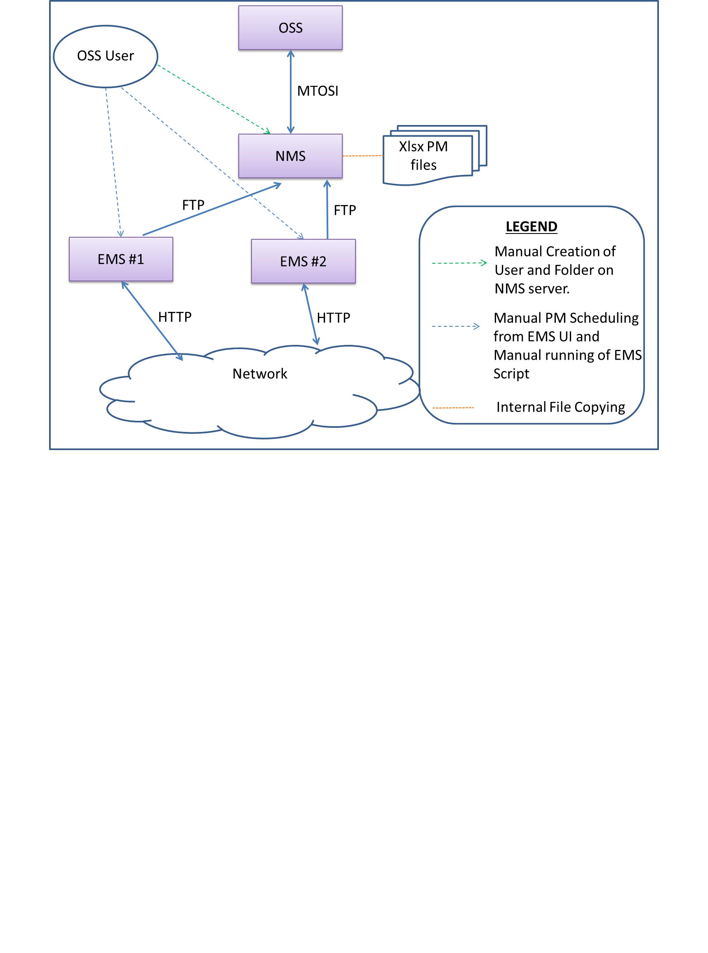

PM Data Retrieval
Tejas will develop a script for collecting PM data for specified objects types at specified duration from all the devices, which are managed by TejNMS.
Following section explains the script in detail.
- Before running the script, user shall enable PM collection for specified Object types or specified Objects from EMS. Once PM collection is enabled, EMS will periodically collect PM data from corresponding devices for the objects, for which PM is enabled.
User can enable PM collection at following granularity
  - At Object Type level: When user wants to collect PM data for say all the SDH ports available in the EMS, he/she shall enable PM collection for the corresponding Object type Port_SDH.
  - At specific object level: When user wants to collect PM data for a specific object instance, say a specific SDH port, he/she shall enable PM collection for the specific SDH port object.
- User shall manually create a userID in NMS server, which will be used by the EMS script for FTP as mentioned in previous step. User shall give appropriate permission to the userID for creating folders and files.
- User shall create folders /home/nms/PM/15MIN and /home/nms/PM/24HR on NMS server. User shall give appropriate permission for writing into these folders. EMS script will FTP the xlsx PM files to this central location.
- User shall install the script on all the EMSs managed by the NMS. The script will periodically read PM data from the internal RRD files, generates xlsx files and FTP transfer the xlsx file to NMS server.
- The script will collect PM data at following frequency.
  - Every 4 hours at 4:00, 8:00, 12:00, 16:00, 20:00 and 24:00, in case of 15 min PM bin/interval
  - Every 12 hours at 2:00 and 14:00, in case of 24 hour PM bin/interval
- The script will store PM data as follows.
  - Format: Excel xlsx
  - Location: /home/nms/PM/<BinType> folder on NMS server. BinType is “15MIN” for 15 min bin and “24HR” for 24 hour bin.
  - File name: PMReport_<EMS Name>_<ObjectType>_<timeStamp>.xlsx (Example: PMReport_EMSBLR1_Port_SDH_05_05_2016_20_00_02.xlsx)
- Based on the maximum rows supported by xlsx file format (i.e., one million rows), four hour of PM data will be kept in each file for each EMS for each object type. As a result, one file will be created for each EMS for each object type for each collection cycle.
- Following Object types are supported.
  - Port_SDH
  - Port_PDH
  - Port_Eth (Ethernet ports)
  - VCG Port
- New PM files xlsx will be generated for each collection cycle and would not be rolled-over. NMS monitors disk usage and raise an alarm of appropriate severity based on percentage of disk being used.

User shall keep monitoring the alarm and shall manually cleanup the xlsx files.

- An example xlsx file, if collected at 20:00 on 5th May 2016 for SDH ports on an EMS EMSBLR1, is attached below. The PM counter values are only for reference.

FM Data Retrieval
TejNMS will support TMF MTOSI NBI for Alarm retrieval. Following sections explain the proposed APIs.

Active Alarm Retrieval
OSS shall use following API to retrieve Active/Outstanding alarms.
  - WSDL: AlarmRetrievalMessages.wsdl available in ResourceTroubleManagement
  - API: getActiveAlarms.
  - Supported Filters: This API will support filtering based on following fields;
      - PerceivedSeverityListType
      - ProbableCauseListType
      - AcknowledgeIndicationType
      - AlarmSourceType
      - NamingAttributeListType
      - QueryExpression - Valid SQL query expression with notification Id (notificationId) or timestamp(ossTimestamp).
      - If the filter is having the QueryExpression then the historical alarms(ordered by notification Id) shall be retrieved instead of active alarms.(Refer 4.2 Query Expression Filter)
  - Batch-wise Data Retrieval: This API will support Iterator for batch-wise data retrieval as explained below.
Request header: Relevant fields are explained below.
- CommunicationPatternType: This field will support MULTIPLE_BATCH_RESPONSE for batch-wise retrieval with the field “RequestedBatchSize” indicating the batch size. SIMPLE_RESPONSE will be supported for non-iterator approach.
Response Header: Relevant fields are explained below.
- IteratorReferenceURI – OSS shall use this URI for batch-wise retrieval.
- Message – This will be “getActiveAlarmsResponse” for Alarms
- BatchSequenceEndOfReply – This field indicates whether any more data is left for retrieval (true/false).
- ActivityStatusEnumType (Success/Failed)
- Timestamp

Active Alarm Count Retrieval
OSS shall use following API to find out total number of Active alarms.
  - WSDL: AlarmRetrievalMessages.wsdl available in ResourceTroubleManagement
  - API: getActiveAlarmsCount
  - Supported Filters: Same as those supported for getActiveAlarms
  - Batch-wise Data Retrieval: Not applicable

HTML version of the WSDL file AlarmRetrievalMessages.wsdl is attached below.

Subscribing For Notification
TejNMS will notify all the subscribed OSS clients with active alarms. OSS shall use following API for subscribing.
WSDL: NotificationProducerMessages.wsdl
API: subscribe
Input: Topic name (String)
Return Value: SubscriptionId (String)

Once the OSS client subscribed successfully it shall start receiving the following types of notifications.
- Alarm notification.
- Heartbeat notification.
- Event loss occurred / cleared notification.

If the OSS client who already subscribed is making the subscription again, then the old subscription id shall be returned.
But in case OSS client is auto unsubscribed due to the exceeding inactivity timeout or the previous subscription is unsubscribed by the OSS client, then the new subscription id shall be returned when OSS client is subscribing again.
Refer 4.8 NMS Hot Standby switchover for the OSS client subscription handling during the HA Switchover.

Alarm Notification
NMS will send the Alarm notification to OSS client whenever the alarms are raised from node and reached NMS for processing.
WSDL : NotificationConsumerHttp.wsdl
API: notify (Sends the notification message of type ‘AlarmType)
Parameter | Description | Example
notificationId | Unique & Sequential numerical id. | 1234589 (Refer 4.1 Notification Id Generation )
sourceTime | Local time in the node when the alarm was last changed | 2019-12-12T12:34:22.698+01:00’
vendorExtensions | Holds the previous notification id details | Refer 4.1 Notification Id Generation
objectType | The affected entity | EMS  MANAGED_ELEMENT  EQUIPMENT
objectName | The name of the equipment or termination point to which the alarm pertains. Otherwise the name of the managed element. | MD=TejEMS-34  ME=192.168.22.201  PTP=TejEMS-34  (Refer 4.4 Additional information in Object name )
osTime | Local time in the NMS when the alarm was notified. | 2019-12-12T12:34:22.698+01:00’
layerRate | TMS supported layerrates | LR_Not_Applicable  LR_STS3c_and_AU4_VC4
isEdgePointRelated | Not set. | N/A
isClearable | Not set. | N/A
aliasNameList | Set EMS name | N/A
probableCause | Set to nearest applicable value,otherwse set to UNIDENTIFIED | ENV  LOF  LOS  UNIDENTIFIED
nativeProbableCause | Native probable cause value in OS otherwise not set. | N/A
additionalText | Set to the alarm text. | Firmware Version Mismatch/Invalid with Software Version
perceivedSeverity | Set to the severity of the alarm. | PS_MAJOR  PS_MINOR  PS_CRITICAL
affectedPtpRefList | Not set | N/A
serviceAffecting | Set as  SA_UNKNOWN  SA_SERVICE_AFFECTING | SA_UNKNOWN
rootCauseAlarmIndication | Not set | N/A
acknowledgeIndication | Set to true if alarms is acknowledged, false otherwise | false
X733_EventType | Not set | N/A
X733_SpecificProblem | Not set | N/A
X733_BackedUpStatus | Not set | N/A
X733_BackUpObjectRef | Not set | N/A
X733_TrendIndication | Not set | N/A
X733_CorrelatedNotificationList | Not set | N/A
X733_MonitoredAttributeList | Not set | N/A
X733_ProposedRepairActionList | Not set | N/A
X733_AdditionalInformation | To hold the link information of the PTP alarms | Refer 4.5 Link information for PTP Alarms
(Table 1.1 Alarm Notification Message format )

Heartbeat Notification
NMS will send the heart beat notification to OSS at the configurable time interval after the successful subscription for notification. Thus OSS client knows that the heart beat sending NMS is still available even if there are no other notifications for some time. The OSS client can conclude that the NMS is unavailable if no heart beat message or any notifications are received.
WSDL : NotificationConsumerHttp.wsdl
API:notify (Sends the Heartbeat Message of type ‘HeartBeatType’)
The following properties are applicable to configure the heartbeat notifications in mtosi.properties.(Refer 4.6 Configure MTOSI Services - NMS System)
HEARTBEAT_INTERVAL | Interval in milliseconds for heartbeat message notifications
HEARTBEAT_FAILURE_RETRY_COUNT | The minimum retry count to be made before making the subscription as inactive.

Event Loss occurred/cleared Notification
NMS will send the Event Loss occurred/cleared event in case of the following scenarios.
- Add new EMS and Alarms are added/deleted in Alarm Table.
- Add new MEs and Alarms are added/deleted in Alarm Table.
- Force resync of EMS for Alarms.
- Force resync of MEs for Alarms.
However the event loss occurred / cleared notifications shall be not be sent in case of add/delete of EMS/ME without alarm update. In such case the resync of alarms to be done after getting the object creation/deletion notification from inventory OSS.

Event Loss occurred Notification
Once the event loss is detected in NMS the event loss occurred event shall be sent.
WSDL : NotificationConsumerHttp.wsdl
API:notify (Sends the notification Message of type ‘EventLossOccured’)
Parameter | Description | Example
Topic | The Topic on which the event loss occured. | Alarm
objectType | Type of object where EventLoss occured. Currently supported types are EMS , MANAGED_ELEMENT | EMS  MANAGED_ELEMENT
objectName | RDN List of Object name | <ns13:objectName>  <ns5:rdn>  <ns5:type>MD</ns5:type>  <ns5:value>EMS-159</ns5:value>  </ns5:rdn>  <ns5:rdn>  <ns5:type>OS</ns5:type>  <ns5:value>EMS-159</ns5:value>  </ns5:rdn>  </ns13:objectName>
(Table 1.2 Event Loss occured Event format)
Event Loss Cleared Notification
Once the event loss is detected in NMS the event loss occurred event shall be sent and the corresponding Event Loss cleared event shall be sent once all the Alarms are updated with the latest entries in NMS system. The OSS client should resync the alarms for retrieving the missing events once it received the Event Loss cleared event.
WSDL : NotificationConsumerHttp.wsdl
API:notify (Sends the notification Message of type ‘EventLossCleared’)
Parameter | Description | Example
Topic | The Topic on which the event loss occured. | Alarm
objectType | Type of object where EventLoss occured. Currently supported types are EMS , MANAGED_ELEMENT | EMS  MANAGED_ELEMENT
objectName | RDN List of Object name | <ns13:objectName> <ns5:rdn> <ns5:type>MD</ns5:type>  <ns5:value>EMS-159</ns5:value>  </ns5:rdn>  <ns5:rdn>  <ns5:type>OS</ns5:type>  <ns5:value>EMS-159</ns5:value>  </ns5:rdn>  </ns13:objectName>
(Table 1.3 Event Loss cleared Event format)

Unsubscribing For Alarm Notification
Once an OSS client unsubscribes, TejNMS will stop notifying it with active alarms,heartbeat notification and event loss occured/cleared notification. OSS shall use following API for unsubscribing.
  - WSDL: NotificationProducerMessages.wsdl
  - API: unsubscribe
  - Input: SubscriptionID (String)
  - Return : UnsubscribeResponse

FM Data Handle
TejNMS shall provide the following FM Data handling MTOSI APIs for OSS client.
- Acknowledge Alarms
- UnAcknowledge Alarms

Acknowledgement For Alarm Notification
OSS shall acknowledge one or more active alarms using this API. The OSS Client will be notified in case the alarm acknowledgment is successful. The acknowledgment operation may involve with several intermediate systems in NMS.
WSDL : AlarmHandlingHttp.wsdl in ResourceTroubleManagement
API: acknowledgeAlarms
Input: AcknowledgeAlarmsRequest
Input field :
Class : AcknowledgeAlarmsRequest
Field | Description
acknowledgeAlarmsRequest.AlarmOrTcaIdListType | Holds the list of Alarms of type AlarmOrTcaIdType
acknowledgeAlarmsRequest.username | user who acknowledges alarms
acknowledgeAlarmsRequest.notepad | notes to be updated on the alarms after acknowledgement

Output : AcknowledgeAlarmsResponse
Output Field :
Class : AcknowledgeAlarmsResponse
Field | Description
failedAcknowledgeIdList | Holds the list of Alarms (of type AlarmOrTcaIdType ) failed in acknowledgment

Return Status - Success:
The failed acknowledgeIdList shall be empty indicating that all alarms are successfully acknowledged.
Return Status - Failure:
In case of failure the failed acknowledgeIdList shall be holding the list of Alarms which failed during the acknowledgement.
In case of any exception (like invalid input or DB unavailable etc..) AcknowledgeAlarmsException shall be thrown.

UnAcknowledgement For Alarm Notification
OSS shall un-acknowledge one or more active and acknowledged alarms using this API. The OSS Client will be notified in case the alarm un-acknowledgment is successful.
WSDL : AlarmHandlingHttp.wsdl in ResourceTroubleManagement
API: unacknowledgeAlarms
Input : UnAcknowledgeAlarmsRequest
Input Request field :
Class : UnAcknowledgeAlarmsRequest
Field | Description
AlarmOrTcaIdListType | Holds the list of Alarms of type AlarmOrTcaIdType
username | user who unacknowledges alarms
notepad | notes to be updated on the alarms after unacknowledgement

Output : UnAcknowledgeAlarmsResponse
Output Response Field:
Class : UnAcknowledgeAlarmsResponse
Field | Description
failedUnacknowledgeIdList | Holds the list of Alarms (of type AlarmOrTcaIdType ) failed in unacknowledgment

Return Status - Success:
The failed unacknowledgeIdList shall be empty indicating that all alarms successfully unacknowledged.
Return Status - Failure:
In case of failure the field acknowledgeIdList shall be holding the list of Alarms which failed during the unacknowledgement.
In case of any exception (like invalid input or DB unavailable etc..) UnAcknowledgeAlarmsException shall be thrown

FM Data Control
TejNMS shall provide the following proprietary APIs for controlling the Alarm notifications for the OSS client.
- Block Alarm Processing
- Unblock Alarm Processing

Block Alarm Processing
This operation enables alarm reporting. Alarm reporting may be disabled for managed objects, in which case alarms from only the said objects are turned off. Alarm reporting for child or parent objects will continue to be in their previous state.
WSDL: TejAlarmControlHttp.wsdl in TejResourceTroubleManagement
API: blockAlarms
Input : TejBlockAlarmsRequest

Input Request Field:

Class : TejBlockAlarmsRequest
Field | Description
alarmProcessingFilter | Holds the list of Alarms Filter of type TejAlarmProcessingFilter

Class : TejAlarmProcessingFilter
Field | Description | Example
equipmentorHolderName | List of object names for which alarm reporting must be blocked. | <ns2:equipmentOrHolderName>  <ns4:rdn>  <ns4:type>MD</ns4:type>  <ns4:value>EMS-112</ns4:value>  </ns4:rdn>  <ns4:rdn>  <ns4:type>OS</ns4:type>  <ns4:value>172.21.3.12</ns4:value>  </ns4:rdn>  <ns4:rdn>  <ns4:type>ME</ns4:type>  <ns4:value>192.11.23.112</ns4:value>  </ns4:rdn>  </ns2:equipmentOrHolderNam>
probableCauseEnumList | List of ProbableCause List for which alarm reporting must be blocked. | <ns2:probableCauseEnumList>  <ns2:probableCause>LOS</ns2:probableCause>  </ns2:probableCauseEnumList>
probableCauseQualifierList | List of ProbableCause List for which alarm reporting must be blocked. | <ns2:probableCauseQualifierList>  <ns2:probableCauseQualifier>Probable Cause</ns2:probableCauseQualifier>  </ns2:probableCauseQualifierList>
serviceAffectingList | List of Service affecting for which alarm reporting must be blocked. | <ns2:serviceAffectingList>  <ns2:serviceAffecting>SA_SERVICE_AFFECTING</ns2:serviceAffecting>  </ns2:serviceAffectingList>
perceivedSeverityList | List of severity for which alarm reporting must be blocked. | <ns2:perceivedSeverityList> <ns3:perceivedSeverity>  PS_CLEARED  </ns3:perceivedSeverity>  </ns2:perceivedSeverityList>

Note: If the equipmentOrHolderName is specified then the block alarm Processing (for the filters equipmentorHolderName, probableCauseEnumList, probableCauseQualifierList ,serviceAffectingList, perceivedSeverityList) shall be done on the EMS specified by the equipmentorHolderName. If the equipmentorHolderName is not specified in the input then the alarm processing (for the filters equipmentorHolderName, probableCauseEnumList, probableCauseQualifierList, serviceAffectingList, perceivedSeverityList ) shall be done across all the EMSs.

Output: TejBlockAlarmsResponse

Output Response Field:

Class : TejBlockAlarmsResponse
Field | Description
failedalarmProcessingFilter | Holds the list of Alarms filters failed in Block Alarm – of type TejResponseAlarmProcessingFilter

Class : TejResponseAlarmProcessingFilter
Field | Description
alarmProcessingFilter | Alarms filter of type TejAlarmProcessingFilter failed in Block Alarm.
Rdn | RDN of Managing Domain where the block alarm failed.

Return status - Success :
The failedalarmProcessingFilter shall be holding the empty list of Alarm Filters.
Return Status - Failure :
In case of failure the failedalarmProcessingFilter shall be holding the list of Alarms filters which failed during the block Alarm process.

In case of any exception (like invalid input or DB unavailable etc..)TejBlockAlarmsException shall be thrown.

Unblock Alarm Processing
This operation enables alarm reporting.Alarm reporting may be enabled for managed objects, in which case alarms from only the said objects are turned on. Alarm reporting for child or parent objects will continue to be in their previous state. Alarm reporting may also be enabled for certain qualifier defined by probable cause qualifier.
WSDL: TejAlarmControlHttp.wsdl in TejResourceTroubleManagement
API: unblockAlarms
Input : TejUnblockAlarmsRequest

Input Request Field:

Class : TejUnblockAlarmsRequest
Field | Description
alarmProcessingFilter | Holds the list of Alarms Filter of type TejAlarmProcessingFilter

Class : TejAlarmProcessingFilter
Field | Description | Example
equipmentorHolderName | List of object names for which alarm reporting must be unblocked. | <ns2:equipmentOrHolderName>  <ns4:rdn>  <ns4:type>MD</ns4:type>  <ns4:value>EMS-112</ns4:value>  </ns4:rdn>  <ns4:rdn>  <ns4:type>OS</ns4:type>  <ns4:value>172.21.3.12</ns4:value>  </ns4:rdn>  <ns4:rdn>  <ns4:type>ME</ns4:type>  <ns4:value>192.11.23.112</ns4:value>  </ns4:rdn>  </ns2:equipmentOrHolderName>
probableCauseEnumList | List of ProbableCause List for which alarm reporting must be unblocked. | <ns2:probableCauseEnumList>  <ns2:probableCause>  LOS  </ns2:probableCause>  </ns2:probableCauseEnumList>
probableCauseQualifierList | List of ProbableCause Qualifier List for which alarm reporting must be unblocked. | <ns2:probableCauseQualifierList>  <ns2:probableCauseQualifier>Probable Cause</ns2:probableCauseQualifier>  </ns2:probableCauseQualifierList>
serviceAffectingList | List of Service affecting for which alarm reporting must be unblocked. | <ns2:serviceAffectingList>  <ns2:serviceAffecting>  SA_SERVICE_AFFECTING  </ns2:serviceAffecting>  </ns2:serviceAffectingList>
perceivedSeverityList | List of Severity for which alarm reporting must be unblocked. | <ns2:perceivedSeverityList> <ns3:perceivedSeverity>  PS_CLEARED  </ns3:perceivedSeverity>  </ns2:perceivedSeverityList>

Note: If the equipmentOrHolderName is specified then the unblock alarm Processing (specified by the filters equipmentorHolderName,probableCauseEnumList,probableCauseQualifierList,serviceAffectingList,perceivedSeverityList) shall be done on the EMS specified by the equipmentorHolderName. If the equipmentorHolderName is not specified in the input then the alarm processing (specified by the filters equipmentorHolderName, probableCauseEnumList , probableCauseQualifierList, serviceAffectingList, perceivedSeverityList ) shall be done across all the EMSs.

Output : TejUnblockAlarmsResponse

Output Response Field :
Class : TejUnblockAlarmsResponse
Field | Description
failedalarmProcessingFilter | Holds the list of Alarms filters of type TejResponseAlarmProcessingFilter failed in UnBlock Alarm .

Class : TejResponseAlarmProcessingFilter
Field | Description
alarmProcessingFilter | Alarms filter of type TejAlarmProcessingFilter failed in Unblock Alarm.
Rdn | RDN of Managing Domain where the unblock alarm failed.

Return status - Success :
The failedalarmProcessingFilter shall be holding the empty list of Alarm Filters.
Return Status - Failure :

In case of failure the failedalarmProcessingFilter shall be holding the list of Alarms filters which failed during the unblock Alarm process.
In case of any exception (like invalid input or DB unavailable etc..) TejUnBlockAlarmsException shall be thrown.
.

OSS Subscription - Sequence Diagrams

The following section describes the possible scenarios in OSS-NMS subscription and the expected behavior of OSS consumers.

Scenario #1
OSS is connecting to NMS for the first time or after long time of inactivity ( say more than 20 hours )
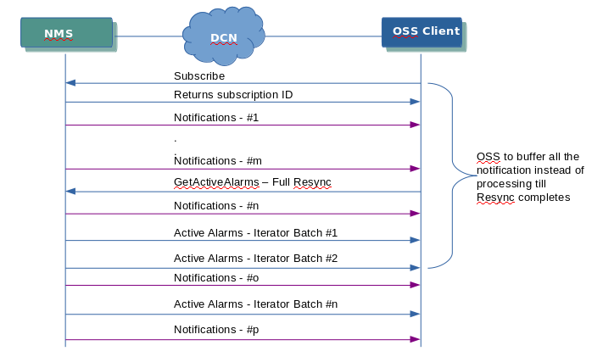

Description
1. OSS needs to subscribe to NMS and start receiving the notifications.
2. OSS to buffer all the notifications received till it completes the Active Alarm Full resync.
3. OSS to perform the Active Alarm Full resync while receiving the notifications in parallel and not to process but buffer the notifications.
4. After Active Alarm Full Resync, the OSS needs to process the notifications in buffer and starts processing other notifications thereafter.

Scenario #2
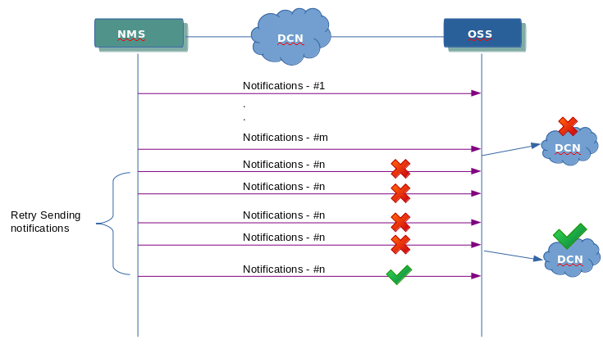
OSS-NMS network connectivity lost or fluctuated for the shorter period of time ( <= 5 minutes)
Description
1. OSS subscribes to NMS and starts receiving & processing the notifications after the resync.
2. The network connectivity between NMS & OSS lost for the shorter period of time ( <= 5minutes).
3. NMS shall be trying to send the notifications and if the sending mechanism fails ,it shall be retried.
4. After some time the network connectivity restored and the notifications to the OSS shall be started from the last retried notification.
5.All the notifications received while doing the retry shall be buffered and sent to OSS once the connectivity restored in sequence.

Scenario #3
OSS client with active subscription experiencing the event loss and doing delta alarms(small set of missed events) resync.

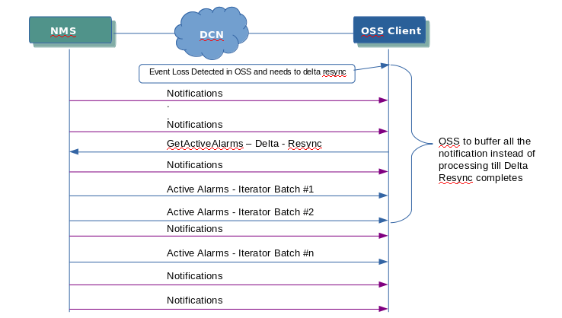
Description
1. OSS subscribes to NMS and starts receiving & processing the notifications after the resync.
2. OSS missed some events.
3. OSS trying to retrieve Active Alarms (delta resync – with notificationid or timestamp filter).
4. OSS is updating with the Active Alarms ( delta resync )
6. The notifications received during the delta resync are buffered.
7.After Active Alarm delta Resync, the OSS needs to process the notifications in buffer and starts processing other notifications received thereafter.

Scenario #4
OSS client with active subscription experiencing the event loss and doing full alarms resync.
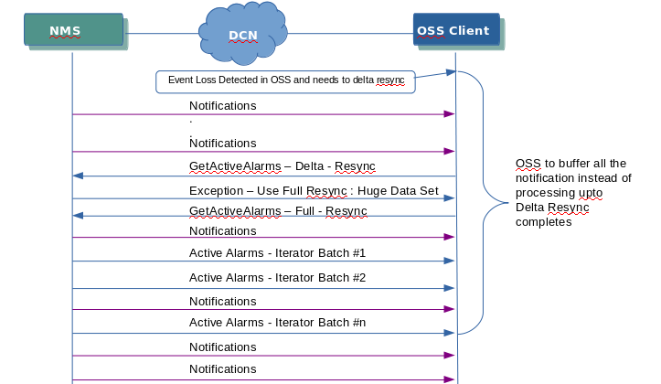

Description
1. OSS subscribes to NMS and starts receiving & processing the notifications after the resync.
2. OSS missed some events.
3. OSS trying to retrieve Active Alarms (delta resync – with notificationid or timestamp filter).
4. NMS detects that the huge set of alarms history to be sent and exception is intimated to the OSS.
5. OSS is doing the Active Alarms ( Full resync )
6. The notifications received during the Full resync are buffered.
7. After Active Alarms Full Resync, the OSS needs to process the notifications in buffer and starts processing other notifications thereafter.

Scenario #5
OSS client with active subscription reboots.

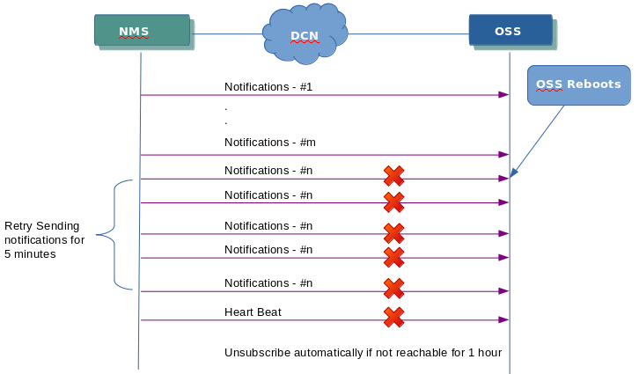

Description
1. OSS client subscribes to NMS and starts receiving & processing the notifications after the resync.
2. OSS client restarts.
3. NMS shall be trying to send the notifications for 5 minutes and if it is not reachable, it shall be assumed as inactive. Only heart beats shall be tried to send to OSS client after 5 minutes.
4. If OSS client not reachable within an hour NMS shall unsubscribe the OSS client.

Appendix

Notification Id Generation
NMS will generate the unique and sequential notification Id for all the notifications sent to OSS consumer. Thus OSS can now track all the notifications from NMS and detect the missing events based on the notification Id. The notification Id shall be persisted in the DB (NMS System) so that in case of HSB switchover the notification id details shall be already available with all the Slave NMS system. The new Master which comes up after the HSB Switch over shall continue the notification Id sequence. In addition to the current notification Id, the latest notification Id tried on the consumer also be available in all the notifications.
The field details for notification ID as below.
Field : EventInformationType.notificationId
The field details for previous notification ID as below.
Field : EventInformationType.vendorExt
The field EventInformationType.vendorExt shall hold the latest notification Id tried on the current OSS consumer subscription. The vendorExt element is DOM Element and has the xml of the following structure with the two attributes NotificationId & Topic
<PrevNotification NotificationId="NotificationID" Topic="TopicID" />
For eg. <PrevNotification NotificationId="1222" Topic="Alarm" />

Query Expression Filter
The query expression filter is defined for the following APIs in FM Data retrieval.
- GetActiveAlarms
- GetActiveAlarmsCount
The valid expression shall be the sql query expression using notification id(notificationId) and timestamp (ossTimestamp). When query expression is defined , the retrieval of historical alarms shall be retrieved instead of active alarms.
Eg.
notificationId > 1222
ossTimestamp > ‘2019-12-12T12:12:22.445’
notificationId > 1222 and ossTimestamp > ‘2019-12-12T12:12:22.445’
notificationId > 1222 or ossTimestamp > ‘2019-12-12T12:12:22.445’
ossTimestamp should be in the format of yyyy-MM-dd'T'HH:mm:ss.SSS.

Buffering of notifications
All the alarm notifications to be notified for the OSS consumers shall be buffered in NMS system in case of failure of notification process. The number of notifications to be buffered shall be configured via configuration parameter (CONSUMER_QUEUE_SIZE) in mtosi.properties (Refer 4.6 Configure MTOSI Services - NMS System ) file. The buffering of the notifications is applicable for the below scenario.
- Network Connectivity fluctuation – Network connectivity between OSS & NMS is experiencing the fluctuated network connectivity. In such case the notifications shall be buffered and retried.
- Temporary and short period network connectivity lost.
In case the OSS consumer is not reachable for longer period of time and the allocated buffer is full, the buffer shall be cleared and NMS shall be waiting for the OSS consumer to be available.
The following property is applicable for defining the buffer size of the notifications in NMS.
CONSUMER_QUEUE_SIZE | The buffer size defined per OSS consumer to buffer the notifications.

Additional information in Object name
For all the Alarm notifications sent to OSS client from NMS, all the fields in the TMF Object name (received from NMS SBA) shall be included in the object name field.
Object Name is represented as Name Attribute value pair (RDN). The “name” attribute in TMF shall be translated into MTOSI name as per the below table.

TMF814 IDL field name values | XML RDN type values
name=”AID” | AID
name=”ASA” | ASA
name=”ASAP” | ASAP
name=”CTP” | CTP
name=”EquipmentHolder” | EH
name=”EPGP” | EPG
namee=”Equipment” | EQ
name=”FlowDomain” | FD
name=”FDFr” | FDFR
name=”FTP” | FTP
name=”GTP” | GTP
name=”EMS” | MD
name=”ManagedElement” | ME
name=”MFD” | MFD
name=”MultiLayerSubnetwork” | MLSN
name=”EMS” | OS
name=”PGP” | PG
name=”PMP” | PMP
name=”PTP” | PTPhttps://localhost/nmsnbi/mtosi/test
name=”SubnetworkConnection” | SNC
name=”TCProfile” | TCPROFILE
name=”TCAPP” | TCAPP
name=”TopologicalLink” | TL
name=”TransmissionDescriptor” | TMD
name=”TPPool” | TPPOOL
name=”TCProfile” | TCP

For eg the Object of type AID shall be represented as below on which the highlighted is the additional information being sent.
<ns2:objectName>
<ns3:rdn>
<ns3:type>MD</ns3:type>
<ns3:value>EMS-180</ns3:value>
</ns3:rdn>
<ns3:rdn>
<ns3:type>ME</ns3:type>
<ns3:value>10.51.106.124</ns3:value>
</ns3:rdn>
<ns3:rdn>
<ns3:type>OS</ns3:type>
<ns3:value>EMS-180</ns3:value>
</ns3:rdn>
<ns3:rdn>
<ns3:type>ME</ns3:type>
<ns3:value>10.51.106.124</ns3:value>
</ns3:rdn>
<ns3:rdn>
<ns3:type>AID</ns3:type>
<ns3:value>10.51.106.124</ns3:value>
</ns3:rdn>
<ns3:rdn>
<ns3:type>PREV_SEVERITY</ns3:type>
<ns3:value>2</ns3:value>
</ns3:rdn>
<ns3:rdn>
<ns3:type>pid</ns3:type>
<ns3:value>2</ns3:value>
</ns3:rdn>
<ns3:rdn>
<ns3:type>IPAddress</ns3:type>
<ns3:value>10.51.106.124</ns3:value>
</ns3:rdn>
<ns3:rdn>
<ns3:type>ObjectLabel</ns3:type>
<ns3:value>10.51.106.124</ns3:value>
</ns3:rdn>
<ns3:rdn>
<ns3:type>ManagedElementName</ns3:type>
<ns3:value>GMPLS_106_224</ns3:value>
</ns3:rdn>
</ns2:objectName>

Link information for PTP Alarms
NMS will include the Link information for PTP alarms if the link information is available in system. The link information shall be added in the <X733_AdditionalInformation> field as follows.
<link xmlns:ns2="http://www.tmforum.org/mtop/fmw/xsd/nam/v1">
<sourceLabel>STM1-1-5-6</sourceLabel>
<destLabel>STM1-1-5-6</destLabel>
<sourceObjectName>
<ns2:rdn>
<ns2:type>MD</ns2:type>
<ns2:value>EMS-159</ns2:value>
</ns2:rdn>
<ns2:rdn>
<ns2:type>ME</ns2:type>
<ns2:value>10.51.148.13</ns2:value>
</ns2:rdn>
<ns2:rdn>
<ns2:type>OS</ns2:type>
<ns2:value>EMS-159</ns2:value>
</ns2:rdn>
<ns2:rdn>
<ns2:type>PTP</ns2:type>
<ns2:value>/shelf=1/slot=5/port=6</ns2:value>
</ns2:rdn>
</sourceObjectName>
<destObjectName>
<ns2:rdn>
<ns2:type>MD</ns2:type>
<ns2:value>Default</ns2:value>
</ns2:rdn>
<ns2:rdn>
<ns2:type>ME</ns2:type>
<ns2:value>10.51.148.7</ns2:value>
</ns2:rdn>
<ns2:rdn>
<ns2:type>OS</ns2:type>
<ns2:value>Default</ns2:value>
</ns2:rdn>
<ns2:rdn>
<ns2:type>PTP</ns2:type>
<ns2:value>/shelf=1/slot=5/port=6</ns2:value>
</ns2:rdn>
</destObjectName>
</link>

Configure MTOSI Services - NMS System
The MTOSI Services shall be configured by mtosi.properties file located at /opt/nms/<NMS_RELEASE_FOLDER>/<APACHE_INSTALLED_FOLDER>/webapps/nmsnbi/conf/mtosi.properties. The following properties are defined in mtosi.properties which could be customized based on the deployment scale and requirement.
Property | Description
HEARTBEAT_INTERVAL | The interval in milliseconds to send the Heartbeat notification from NMS to OSS Client ( Subscribed consumer )
CONSUMER_QUEUE_SIZE | The buffer to be allocated per consumer of OSS Client to handle the retry in case of network non-availability or temporary non availability of OSS Client
HEARTBEAT_FAILURE_RETRY_COUNT | The number of heart beat to be retried for the unavailable OSS Client before marking the client is inactive.
NOTIFICATION_RETRY_COUNT | The number of times the notifications like Alarm , Event Loss occurred, Event Loss Cleared to be retried.
NOTIFICATION_RETRY_INTERVAL | The time interval in milliseconds for retrying the notification in case of notification failure for OSS client.
EVENT_HISTORY_MAX_ROWS_IN_SIMPLE_RETRIEVAL_MODE | The maximum number of rows to be retrieved in the Simple retrieval mode for GetActiveAlarms API.
EVENT_HISTORY_MAX_ROWS_IN_BATCH_RETRIEVAL_MODE | The maximum number of rows to be retrieved in the batch retrieval mode for GetActiveAlarms API

Tejas Proprietary API - Alarm Control
TejResourceTroubleManagement is the Tejas provided proprietary API for block and unblock alarms.
The TejResourceTroubleManagement specification uses and refers the MTOSI defined datasets as well. It should be considered in the same level as in ResourceTroubleManagement for converting the wsdl to java.
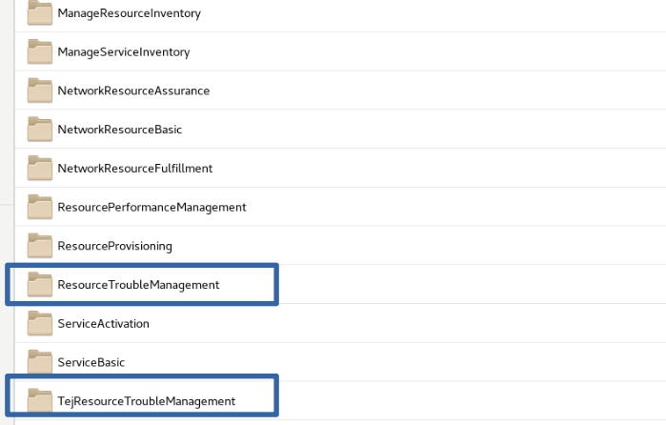

NMS Hot Standby switchover
The NMS System with hot standby setup (Master & Slave) provides high availability and the following explains the NMS system setup and the mechanism of OSS client Subscription.

OSS Client subscribed to Primary Site Master NMS system via Virtual IP
When the NMS Master system is available , all the subscribed OSS client shall be receiving the heartbeat messages and notifications from Master NMS.
If the OSS is not receiving the notifications or heartbeat messages over a period of time (configured by HEARTBEAT_INTERVAL) then the OSS shall assume that NMS is not reachable or not available.

OSS Client subscription handling at Slave NMS System in Primary Site after HA Switchover
The switchover of the system from Master to Slave NMS shall happen in case of Master NMS is not available.
After the switchover the Slave NMS system shall be made as new Master and the following operations shall be done for the OSS client.
- All the subscribed OSS client already to the previous NMS Master shall be auto subscribed with Slave NMS which is the new NMS Master. The subscription id will be the same as done on previous NMS Master System.
- The OSS client shall not be aware of the switch over and shall start receiving the notifications and heartbeat messages from the Slave-NMS system.
- All the notifications shall be sent in the continuation of the sequence where the previous NMS Master system stopped before the HA Switchover.

Proposed Setup
The following is the proposed setup for the NMS server deployment. It considers and assumes the following.
- The Primary site to host the Master and Slave NMS system.
- Both Master and Slave NMS to connect with same Virtual IP address. The probes are expected to connect to the Primary Site via same Virtual IP address.
- Since both Master and slave NMS systems are available in the same primary site (within the same network), the HA switchover is expected to be fast (within 2 minutes) and provides high availability.
- The DR site to hold one more Slave NMS.

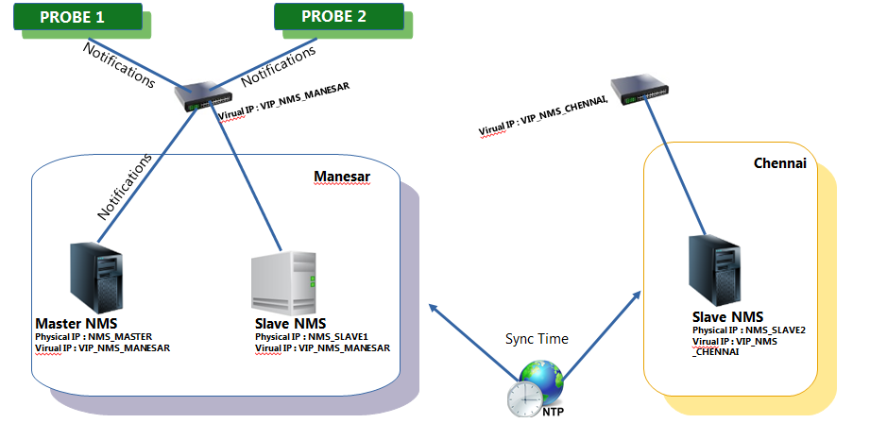
(Probe 1& 2 getting notifications from Master NMS )

- In case of HA Switchover the subscriptions shall be done automatically for the OSS client in NMS system and the notifications shall be continued from the Slave NMS system.

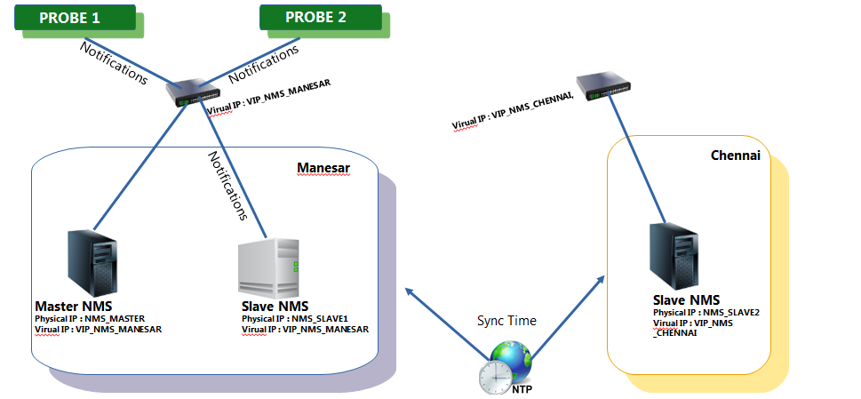
(Probe 1& 2 getting notifications from Slave NMS after HA Switchover)

--End of Document--

