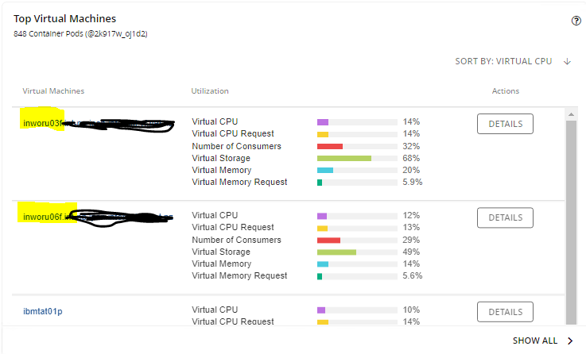

Highlighted “VMs” are really physical baremetal servers, running Redhat.

* 40 core (with hjyperthreading), 256GB of RAM and SAN storage provided via HPE CSI driver controlling a HPE Primera array.

And this is what is shown in the “Entity Information”

