We just want user to run device discovery without granting ‘Device Edit’ privilege because we don’t allow user to change SNMP community strings. Apparently this does not work

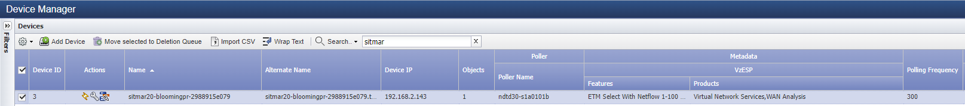

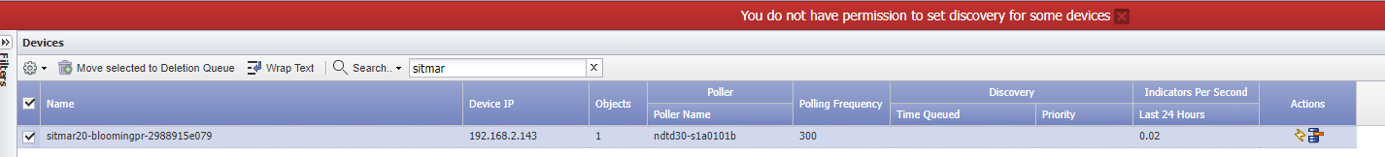

User with this role:

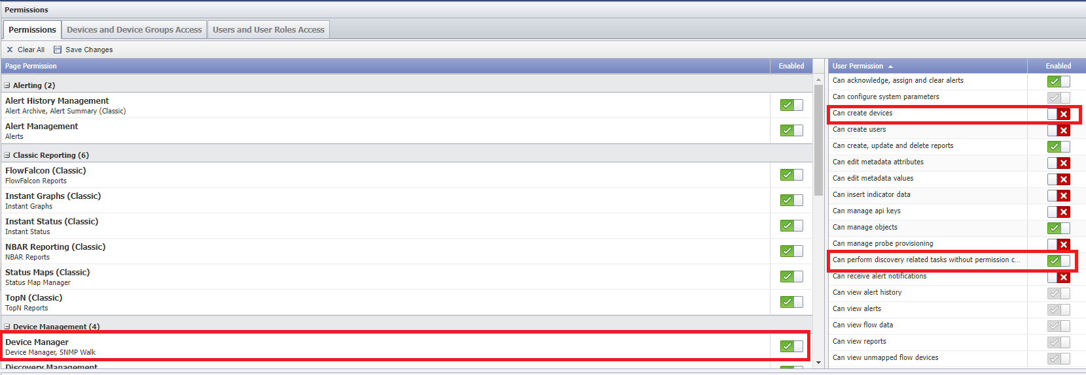

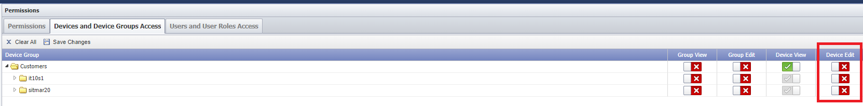

In order to allow user to discovery on the Device Manager, we have to give ‘Device Edit’ privilege:

