NetProfiler – WebEx Client App Traffic byLocation
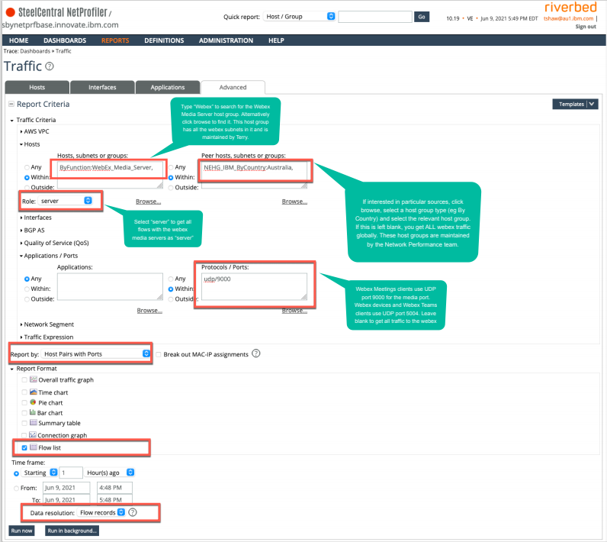

NetProfiler – WebEx Traffic for a Specific WebEx Device
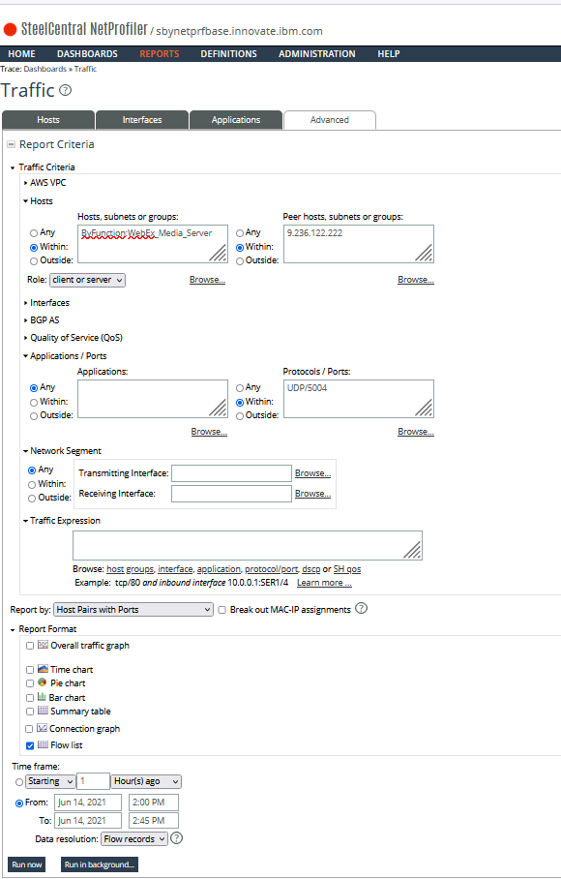

All Traffic for a Specific Device including QoS Flow Records
