Revision Version | Date | Revised By | Approved By | Description
V1.0 | 08.14.2025 | Stan Mefford | Team Reviewed and approved 8.18.2025, 9am CT | Instruction on Cloudability features do not support business mapping setup in the View level.

Introduction

These instructions outline that Cloudability features do not support Business Mappings setup at the View level. Our Views are set up for the proper dimension. Our team has determined that we are maintaining the Business Mapping for most teams and how that’s being used.

Premise
It was initially agreed to set up views using the FinOps Team, but due to Confluent, the Crew team had to revert to Teams to access the data. Features in Cloudability currently have issues with Business Mappings in the Views specifically, Container Insights and Workload Planning
Findings
Submitted a ticket with IBM (TS020057350 )stating that, “Southwest Airlines FinOps team utilize Business Mappings and are aware some tooling doesn't support the View setup with a Business Mapping. Would you please advise what features do not support the Business Mapping set with the Views? For example, last tested, Workload Planning did not support our Views utilizing the Business Mapping. We re-worked all of our Views to an Account Group dimension and the tooling worked fine.”
The the support response from IBM ticket is below: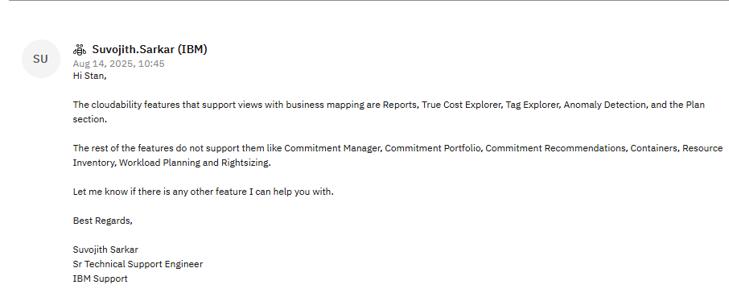

Resolution
Cloudability features that support views with business mapping are:
- True Cost Explorer
- Tag Explorer
- Anomaly Detection
- Plan Section
Cloudability Features that do not support Views with business mapping are:
- Commitment Manager
- Commitment Portfolio
- Commitment Recommendations
- Containers
- Resource Inventory
- Rightsizing
- Workload Planning

Sending an enhancement ticket to the IBM team to ask for these unsupported Views to be added.

